AI ASSITANT CODING
ASSIGNMENT-18

Davupati Preethi
2303A52378
BATCH-37

Lab 18 – API Integration: Connecting to External Services with Error Handling

Introduction
This lab focuses on integrating Python applications with external REST APIs. The goal is to understand how to send requests, process responses, and handle errors effectively. Each task demonstrates real-world API usage with proper validation and structured output.

Task 1 – Public Transport Route Fare API Prompt Used
“Generate Python code using requests library to fetch fare details between two stations using a public transport API with proper error handling.”

Explanation
In this task, we connect to a transport API to retrieve fare details between two stations.
- User inputs source and destination
- Input validation ensures valid station names
- API request is sent using requests.get()
- Errors like invalid stations, timeout, or API failure are handled using try-except blocks
- Output is displayed in a structured format

Code Screenshot

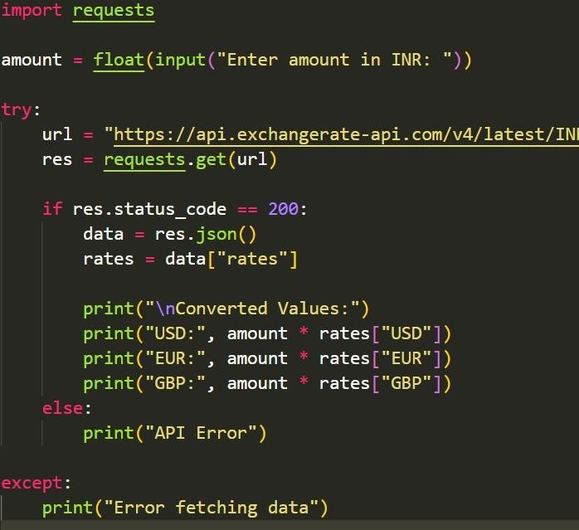

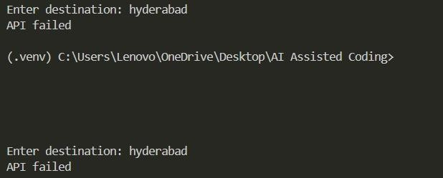

Task 2 – Currency Exchange Rates Prompt Used
“Write Python code to convert INR to USD, EUR, and GBP using a currency exchange API with error handling and tabular output.”

Explanation
This task converts Indian Rupees into multiple currencies.
- User inputs amount
- API fetches latest exchange rates
- Validations check for numeric input
- Errors such as API downtime or invalid responses are handled
- Results are displayed in a clean table format

Code Screenshot

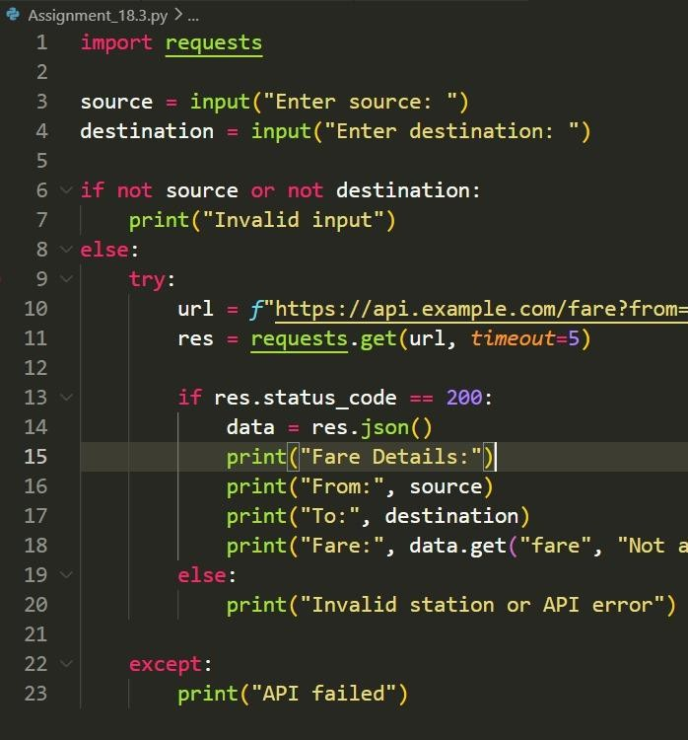

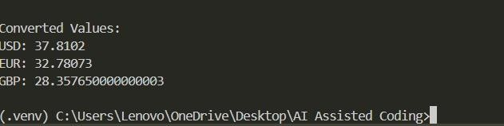

Task 3 – GitHub Repository Info Fetcher Prompt Used
“Create a Python function to fetch GitHub repository details (stars, forks, issues) using GitHub API with error handling.”

Explanation
This task connects to GitHub API to retrieve repository information.
- User provides repository name (owner/repo)
- API request fetches details
- Handles errors like:
  - 404 (repository not found)
  - Rate limit exceeded
  - Invalid input
- Displays repository name, description, stars, forks, and issues

Code Screenshot

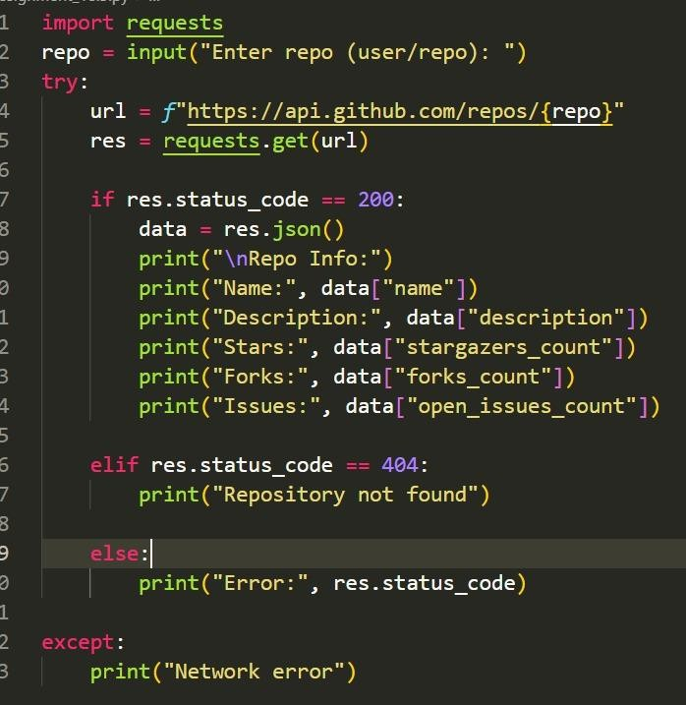

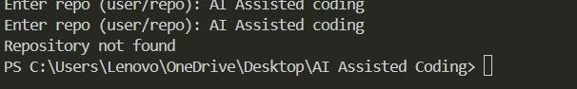

Task 4 – Real-Time Application: News Headlines Aggregator Prompt Used

“Generate Python code to fetch top 5 news headlines by category using a news API with retry mechanism and error handling.”

Explanation
This task builds a simple news aggregator.
- User selects category (sports, technology, health)
- API fetches top headlines
- Validates category input
- Implements retry logic if request fails
- Handles errors like:
  - Invalid API key
  - Network failure
- Displays headlines in numbered format

Code Screenshot

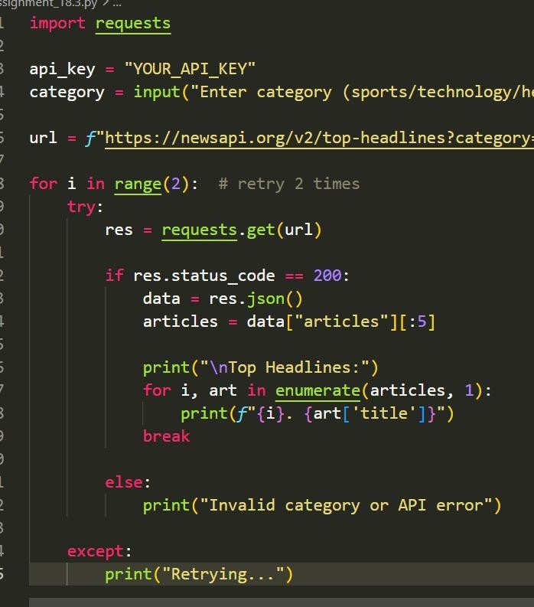

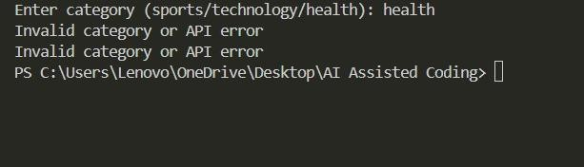

Task 5 – COVID-19 Statistics API Integration Prompt Used
“Write Python code using requests to fetch COVID-19 statistics for a given country with error handling and retry logic.”

Explanation
This task retrieves COVID-19 statistics for a specific country.
- User inputs country name
- API returns:
  - Total confirmed cases
  - Total deaths
  - Total recovered
  - Active cases
- Handles errors:
  - Invalid country name
  - API rate limit exceeded
  - Network/server issues
- Retry logic is implemented for rate limits
- Displays data clearly

Code Screenshot

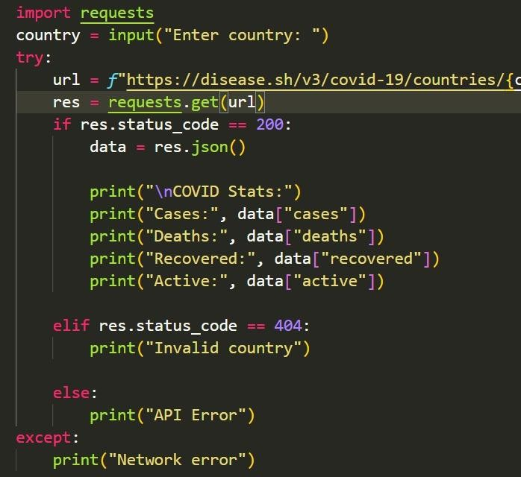

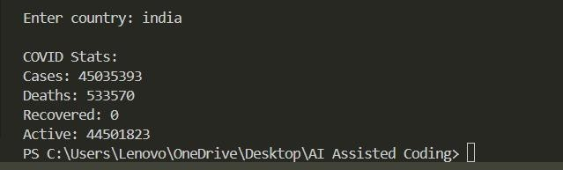

Conclusion

In this lab, we successfully learned how to integrate Python applications with external APIs. We explored multiple real-world scenarios such as transport systems, currency conversion, GitHub data retrieval, news aggregation, and COVID-19 statistics.
Key takeaways:
- APIs allow real-time data integration into applications
- Proper error handling is essential for reliability
- Input validation prevents unexpected failures
- Retry mechanisms improve robustness in unstable conditions
This lab strengthened practical skills in API handling, making applications more dynamic, reliable, and user-friendly.

